**T WAW C**

**TECHNICAL FEATURES**

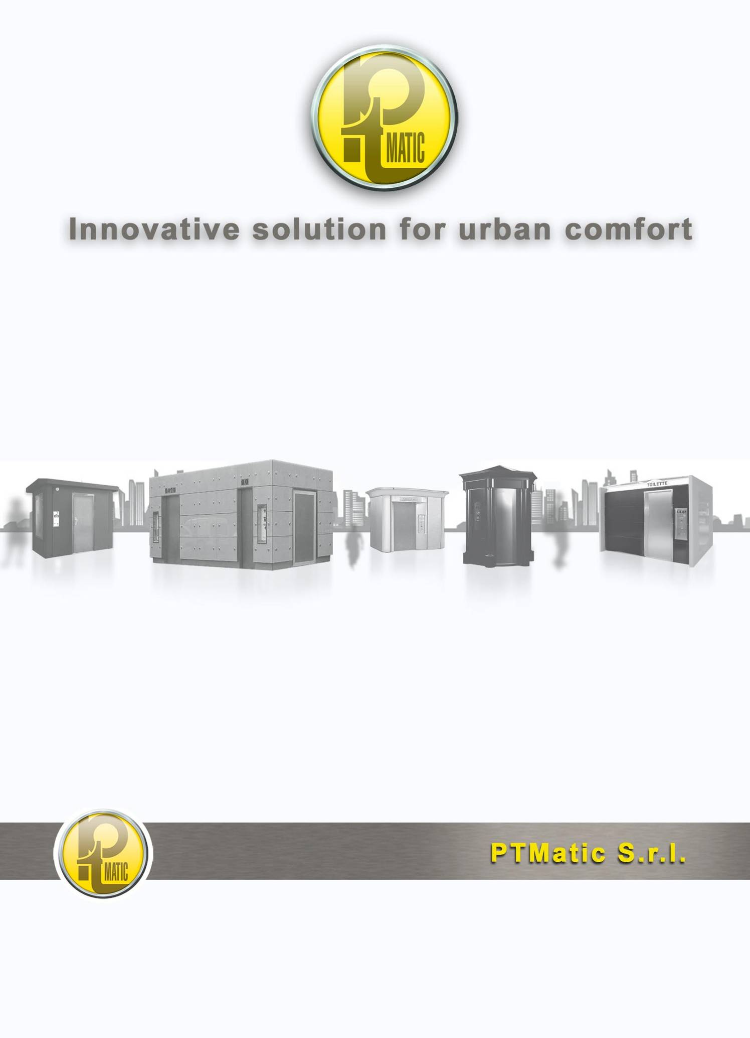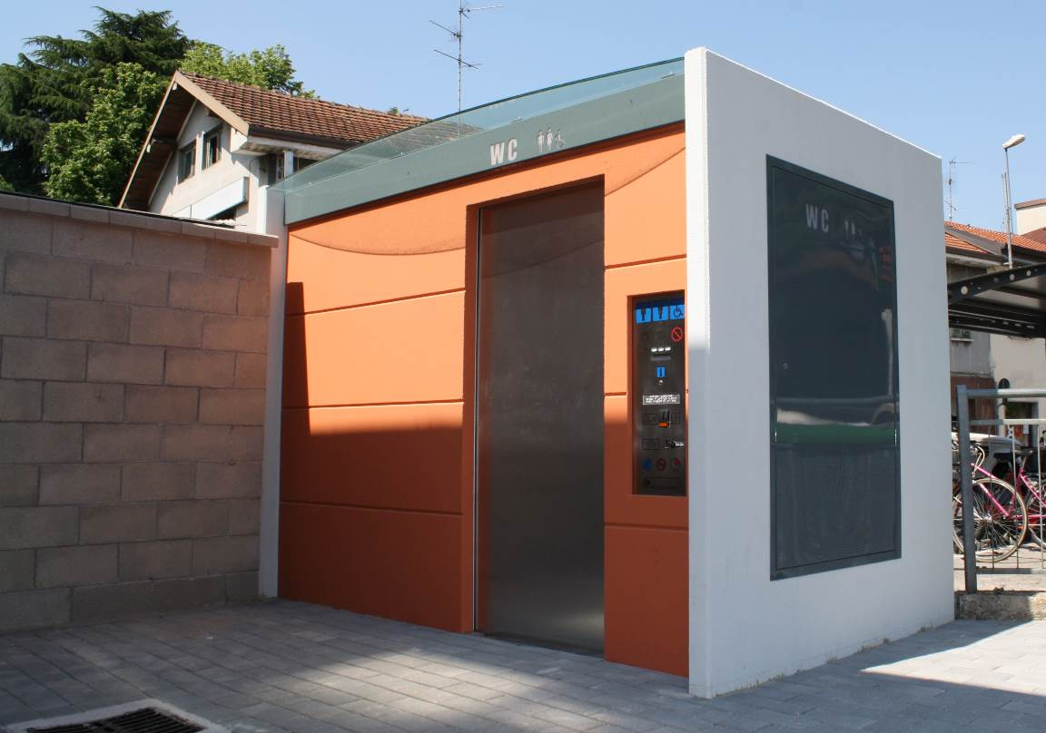

**TMAX**

**FULL AUTOMATIC SELF- CLEANING TOILET**

# SPECIFICATION

The automatic toilet TMAX represents the top as far as design and performance is concerned for an urban automatic self-cleaning sanitary service. The unit is fitted with automatic sliding door for opening and closure, water/soap dispensers and automatic hot air “no Touch”.

The automatic self-cleaning toilet, model TMAX has a rectangle plan. The external sizes are 3.05 m x 2.10 m and height of 2.70 m to the dome top. The regular shape ensures the most contained size with the maximum useful internal area and allows it to easily match the urban structure.

The user room size (m. 2.20 x 1.50 – 1.65 x 2.05) the locations of sanitary devices and their accessories allow its usage by disabled people on wheelchair, and are in conformity with European Law.

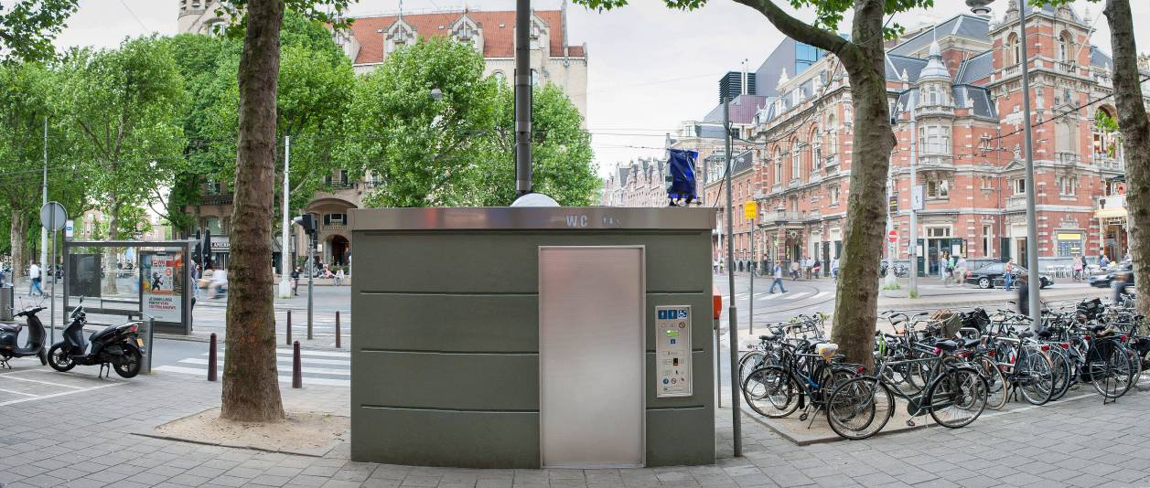

***The main toilet feature is the automatic cleaning with disinfection of :***

**Inside of the WC bowl** through water thin layer during use;

**Inside and outside of the bowl** (expulsion) at the end of its use with sitting surface drying**;**

Inside the hand basin during use;

**Walls,** up to a height of 0.8 m;

**Hand Wash** after each use with specific sprinkler collecting trash to separate bin

**Floor,** providing mechanical removal of waste and drying, in a version with floor wiper. ***Lava;*–Tergipavimento®,** our patent no MI 2005 A001873.

**All toilet** with exclusively Disinfectant cycle, with fog atomizer **DCN® ECO3.** Usingexclusive disinfectant **NOCODOR®** (silver peroxide)

The emergency equipment **prevents to close the door if children not escorted enter in toilet** (minimum weigh control) and **go in alarm if enter in toilet more than one person** (maximum weigh control)

1. The emergency equipment prevents the starter of the operations of washing in presence of the customer to the inside of the toilette.

# STRUCTURE

Concrete Precast monolithic pod fitted with base and drainage pool and all connection couplings for the connection to the urban water, electric, sewage system. This solution allows to greatly simplify the site operational works and prepared concrete foundation. External wall are from mould and can be cladded with large tiles.

**Plane roof** manufactured is designed to allow rainwater flowing into the appropriate sewer. The roof has big natural skylight.

Internal High Pressure Laminates (HPL) walls having panel of 12 mm width. The colour and features are warm and welcoming. The walls are fixed on a stainless steel structure. The interior surfaces are graffiti and fly-posted proof.

The walls finishing is welcoming, light internal colours white based with grey dots patter, lamp allow to create a comfortable and wide space.

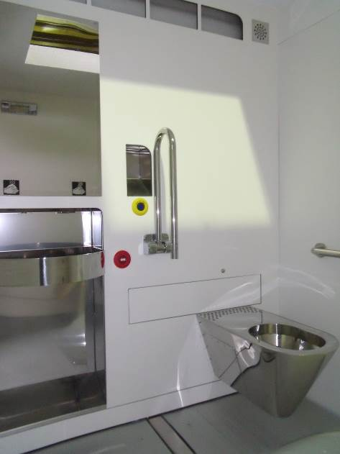

Inside room –

Floor having a aluminium profile on stainless steel frame, surface processed for high resistance and anti-slip made up of stainless steel frame. The whole floor rests on electronic weight detectors which allow to signal the user presence safely.

The skylight dome made of polycarbonate (PMMA), flame-proof and shatterproof fitted with a baffle to allow the forced change air, ensures the day lighting inside the toilet. Its shape and sizes allow a correct natural lighting combination and attenuates the user’s closeness sensation.

Retractable pneumatic sliding door, coated with stainless steel plates. Thermal acoustical insulation is performed through expanded polyurethane. The door opens automatically when the coin is inserted and closes automatically ten second after a person has entered and is manually locked. The APT door will gently reopen if it encounters any obstacle when closing. After reopening it will try to close again. In the event of power failure the door can be opened to use power from pneumatic tank and can be also even manually opened from inside

# FEATURES

Hanging vitreous china bowl. On request in stainless steel.

Stainless steel plates washbasin set built into the wall in position and size so as to allow easiness of use by disabled persons. The wash basin is reachable even while user is sitting on wc. The basin is jet washed as a part of the cleaning cycle.

Automatic water, soap and hot air dispensers for hand drying, controlled by infrared sensors controlled by the microprocessor which are excited by the presence of the user hands. Soap supply is pre-set to avoid waste.

Automatic toilet paper dispenser made of stainless steel Jumbo-Roll type, in a pre-set quantity.

Automatic internal lighting. Emergency internal lighting in case of electrical black out

External vandal resistant panel fitted with a display with warning lights “VACANT/OCCUPIED/ OUT OF ORDER” and door opening device with instruction in Arabic, English and Urdu/Hindi. The display shows when self cleaning cycle is in work.

Display LCD with instructions, to use the toilet and indication of the cause of possible “Out of Work” in four languages. Therefore, the system provides precise diagnostics for all maintenance interventions. Signs on this panel explain the function of the APT.

Stainless steel mirror, clothes hook made of stainless steel, handles for people having physical problems in stainless steel.

Stainless steel trash bin built into the wall fitted with fire-breaking door.

Baby changer- bracket in stainless steel

Emergency button located near the bowl which causes the door opening (even in case of power failure) and activates emergency optical and acoustical alarms. The safety button located on the right of door having ergonomic shape and size, ensures the automatic opening even with power failure, or the manual opening in case of pneumatic system failure.

Time warning system fitted with digital display and emergency signal indicating the remaining three minutes.

Emergency external optical warning device.

Emergency acoustical warning device.

Exit Button

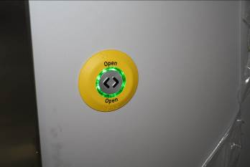

Gruppo lavello in acciaio inox con erogatori “no touch”

wash basin “no touch” distributors

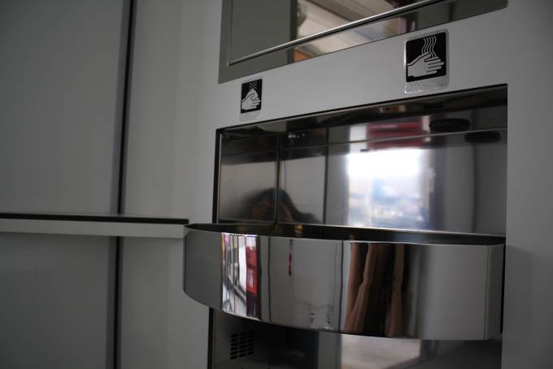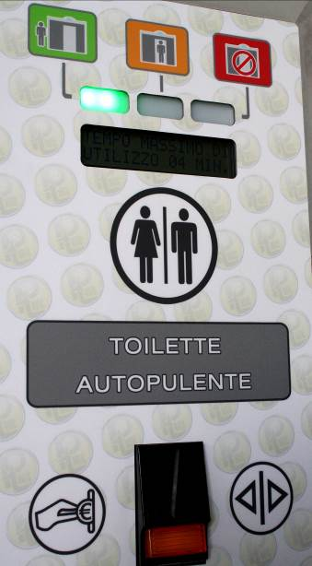

info panel with coin box and LCD display

Stainless steel trash bin

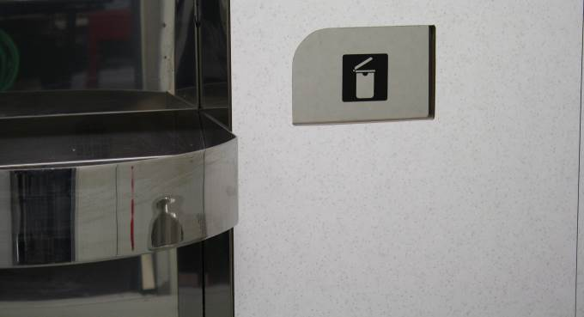

Gruppo lavello in acciaio inox con erogatori “no touch”

# EQUIPMENT

Tank for water added with disinfectant fitted with “no water” control. Water reserve always ensures the washing after use, before putting the toilet “Out of work” for no water.

Disinfectant liquid tank fitted with “low level” control and dosing pump.

Pump of the water circuit of the various washings.

Washing and sanitation device of the bowl outside and for the automatic sitting surface drying. Equipment for the complete bowl washing.

Lava;–Tergipavimento®, automatic device for washing, drying and the removal of objects and waste floor, fitted by alluminium profile, through mobile “floor wiper” device (our Patent no. MI 2005 A001873). This device removes even larger items like soft drink cans, 1,5 litres plastic water bottles, news papers ect. During the cleaning the floor is undergone a cleaning from detergent and disinfectant cycle and mechanical cleaning with brushes and is dried after the cleaning. The cleaning is after every use and takes care of larger items like soft drink cans, news papers, plastic water bottles, napkins etc.

Full disinfection night system DCN® ECO. The only device that disinfected All user cubicle with exclusively cleaning cycle by fog atomizer, using NOCODOR® disinfectant silver peroxide based. These environmentally friendly systems don’t produce any pollution in sewage waters.

Transfer pneumatic unit for the automatic door opening and closure and the activation of the washing and disinfecting system of the bowl.

Detection of person presence through electronic weight detectors (load cells), with safety program for minimum weigh (children safety) and maximum weight ( two person control). Weight sensing system (load cells) does not allow the floor to be cleaned if the weight detectors indicate that the automatic public is still occupied. The complete cleaning cycle does not take more than 60 seconds.

Electromechanical cycle counter which cannot be reset on the electrical panel, electronic which can be displayed.

Ventilation system which ensures the continuous air change inside the user room with about 30 completely changing per hour.

Use timer of the unit, fitted with the automatic opening at the pre-set time end, through optical/acoustical warning. Use of the toilet can be programmable and decided to the municipality on location basis. It can vary from 10 to 25 minutes. The time spent in the toilet is shown on a LED display and clearly counts down in one-minute intervals.

Electronic multicoin-operated box for door opening control, that does not give any change back. Device, coin-collecting box ad usage cycle counter.

Protection and control electrical panel, fitted with differential switch idn 0.03 A and microprocessor for the computerized management of all operations of user presence and toilet washing. The microprocessor allows to change: operating time, unit usage price, time at disposal for the user; disinfectant.



Internal view

**Equipment on request**

**Kit:**

|  |  |
| --- | --- |
| KM50 | **Kit Winter Pro** - solution with the aim to increase Toilette winter environment heating for low temperatures with:   * Winter environment security heating COMFORT PLUS; * Automatic depletion device of the water system for temperatures lower than the expected minimum ones or for power failure; * Thermal and acoustical increase insulation; * Hot water boiler (11). |
| KM51 | **Kit INOX** -solution with stainless steel accessories vandal-proof with:   * Stainless steel wall-hung bowl which replaces ceramic bowl, fitted with overflow control device; * Inox baby-changing table; * Stainless steel handrail for disable users; |
| KM52 | **VistaPT ® -** PT-help-sound system emission with:   * voice instructions and messages to users visually impared; * Internal control buttons (exit, emergency ...) with instructions in Braille and backlit with LEDs; |
| KH53 | **PTEnvironment** - solution for energy saving and environmental conservation with:   * Eco LED - internal Eco Led strip lighting for energy saving; * External LED lighting - low power consuming; * Eco Flush: extra flush device; * DCN-ECO3®, full disinfection night system; * Roof Insulation “grass type”; |

**External finishes:**

|  |  |
| --- | --- |
| ACM14 | **External LED lighting -** low power consuming. |
| ACM30 | **External fine gravel finishing o**r optionally kind. |
| ACM46 | **Glass canopy roof on entrance door.** |
| ACM12 | **Write-proof special paint anti-graffiti enamel.** |
| ACM42 | **Stainless steel external cladding.** |

**Optional:**

|  |  |
| --- | --- |
| ACM01 | **Winter environment security heating device termofan (technical room).** |
| ACM05 | **Multicoin-operated equipment** fitted with coin-collecting box ad usage cycle counter. |
| ACM06 | **Recognition magnetic card reader.** |
| ACM07 | **PT-line-PTMatic Unit remote control** through transmission of “Out of Service” warning by means of the telephone line. |
| ACM10 | **Eurokey-disable European standard key.** |
| ACM15 | **DCN-ECO3® - Full disinfection night system:** toilette cleansing device by fog atomizer, using silver peroxide based disinfectant. These environmentally friendly systems don’t produce any pollution in sewage waters fitted with perfume diffuser . |
| ACM19 | **Solar panel.** |
| ACM20 | **Internal HPL walls printed with images** optionally. |
| ACM25 | **Inox baby-changing table.** |
| ACM35 | **Stainless steel satin door for technical room.** |
| ACM53 | **Eco Flush: extra flush device.** |
| ACM55 | **Anti pollution system.** |
| ACM56 | **Power 380/400 V three-phase.** |
| ACM60 | **Special external door cladding optionally.** |
| ACM69 | **Concrete Precast foundations slab** ready for installation of Toilets. |
| ACM73 | **Retractable Hose bib, hand shower** in stainless steel box with washing wiper fitted with automatic washing system. |
| ACM74 | **Air conditioning system** provided to maintain the right temperature power 10000 BTU. |

# Use Cycle

With the introduction of the currency in the coin box (use to payment) is qualified automatically:

The lighting system of toilette the automatic

The opening of the door

The available time court down

It marks them of "occupied" on the coin box

The increment of an unit of the counter;

The vocal signal (if demanded);

The washing system of the bowl

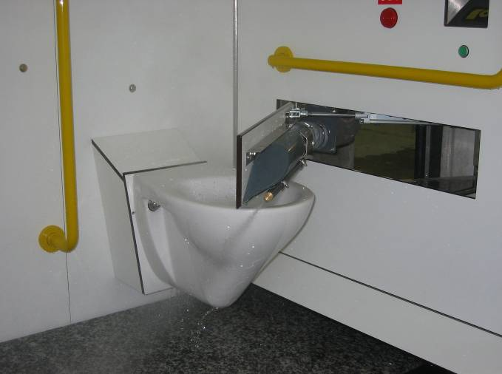

The distribution of the veil in the bowl;

The fan for the ventilation

The distributing ones automatic us of water, soap, air, and of the hygienic paper.

From the moment in which the cabin it comes occupied, the control device, verified the weight on the footrest, it enters in occupied state and come qualified following operazion:

The toilet is illuminated;

The door is closed;

Are activated the control and security systems;

It begins the , the same one is reopened and enters in function the signal (optical and acoustic) of emergency, count down of the maximum time available.

When people To plan in order to exit, the customer presses the handle of the door and of it she commands the automatic opening. The door remains open until the customer is not exited. In the that case the customer or other person re-enters before closing of the door, the same one is reopened and enters in function the signaler (optical andl acoustic) of emergency**.**

When toilet is free, began process:

Closing of the door;

Extinction of the lighting system lamp;

Interruzione del velo d’acqua nella tazza WC;

Interruption of the water veil in cup WC

Switch off of the security systems;

Switch off of automatic dispenser;

Consent for the beginning of the washing cycle and disinfection of the toilette;

Turn on zero time counter.

To the term of the washing cycle, before making available the unit for a successive one I use, it comes verified the efficiency of all the equipment..

floor washing system: “lava Tergi-pavimento”

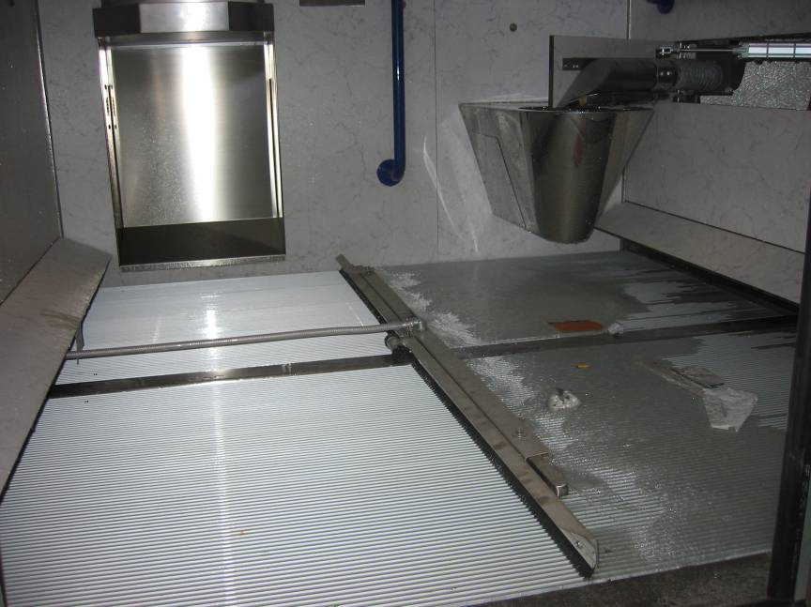

# Tecnical sheet T waw

|  |  |
| --- | --- |
| **Electric** |  |
| Electrical connection without heating or Air con | 220V F.N.3KW |
| Electrical connection with heating / Air condition system | 220V F.N.6KW |
| Minimal section feeding cables | 6 mm2 |
| Current max scattered | 0.03A |
| Electrical and signal voltage | 5, 12, 24V |
| **Plumbing** |  |
| Tube fresh water | ∅ ¾” |
| Minimal pressure of water link | 1,5 atm. |
| Tube drainage dirty water | ∅ 110 mm. |
| Tube drainage floor | ∅ 90 mm. |
| **Tanks capability** |  |
| Water tank | l. 60 |
| Disinfectant tank | l. 10 |
| Disinfectant tank (battery installations) | l. 25 |
| Liquid soap tank | l. 3 |
| **Consumptions (without heating)** |  |
| Water consumption (every cycle) | lt.16 |
| Water consumption of ***Lava;*–Tergipavimento®,** (every cycle, can be adjusted) | lt.5 |
| Disinfectant consumption (every cycle) | cc. 20 |
| Disinfectant NOCODOR consumption with DCN ECO system ( every day) | cc. 7,5 |
| Electricity consumption (every cycle) | 20 W |
| Pre set toilet paper quantity | Till 99 |
| Pre set toilet paper autonomy | 400 pieces |
| **Cycles times** |  |
| Length of washing, disinfection and drying system | 55 seconds |